**Lab program 4**

abstract class Animal {

abstract void eat();

abstract void sleep();

}

class Lion extends Animal{

void eat(){

System.out.println("Lion is an carnivore animal");

}

void sleep(){

System.out.println("Lion is sleeping");

}

}

class Tiger extends Animal{

void eat(){

System.out.println("Tiger is an carnivore animal");

}

void sleep(){

System.out.println("Tiger is sleeping");

}

}

class Deer extends Animal{

void eat(){

System.out.println("Deer is an Herbivorous animal");

}

void sleep(){

System.out.println("Deer is sleeping");

}

}

class Mainanimal{

public static void main(String[] args){

Lion l1 =new Lion();

l1.eat();

l1.sleep();

Tiger t1 =new Tiger();

t1.eat();

t1.sleep();

Deer d1 =new Deer();

d1.eat();

d1.sleep();

}

}

Output

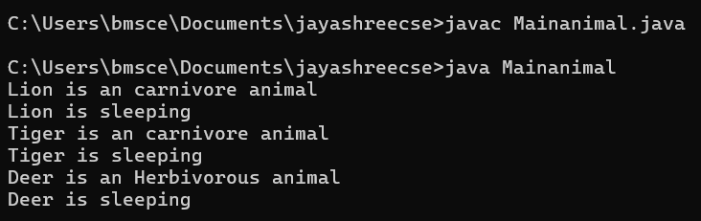

abstract class Shape{

int dim1;

int dim2;

abstract void printarea();

}

class Rectangle extends Shape {

Rectangle (int length ,int breadth){

dim1=length;

dim2=breadth;

}

void printarea(){

System.out.println("the area of rectangle is "+ dim1*dim2);

}

}

class Triangle extends Shape {

Triangle (int base ,int height){

dim1=base;

dim2=height;

}

void printarea(){

System.out.println("the area of Triangle is "+ 0.5* dim1+dim2);

}

}

class Circle extends Shape {

int radius;

Circle (int r){

radius=r;

}

void printarea(){

System.out.println("the area of circle is "+ 3.14*radius*radius);

}

}

class Mainmath{

public static void main(String[] args){

Rectangle r1 =new Rectangle(10,20);

r1.printarea();

Triangle t1 =new Triangle(10,25);

t1.printarea();

Circle c1 =new Circle(6);

c1.printarea();

}

}

